Audience
The primary audience for this data story is adults between the ages of 18 and 45 who are car owners, social media users, or both. This group is most likely to have encountered the "Kia Boys" trend online and may own one of the affected vehicles without fully understanding the scale of the crisis or their legal and safety options. A secondary audience could include consumer advocacy groups, local policymakers, and journalists who can amplify the call to action.

Purpose
The purpose of this story is to inform and advocate. While the Kia/Hyundai theft vulnerability received viral attention on TikTok and scattered news coverage, most consumers lack a clear picture of how widespread the problem became, how quickly it escalated, and how unevenly the burden fell across American cities. This story uses data visualization to make those patterns undeniable and to push readers toward action: checking their vehicle's recall status and demanding that manufacturers fully fund the fix.

Medium
The story is designed as a presentation in the style of investigative data journalism. This allows narrative text and data visuals to work together. The reader is guided through the data progressively, from national scale down to Milwaukee's extreme case. The digital format will include charts, shareable graphics, and direct links to recall databases and petitions, all of which support the call to action.

Design
A consistent two-color palette was used throughout: orange for Kia/Hyundai thefts and blue for all other vehicles. A light neutral background keeps the visuals clean and readable on screens. Chart types were selected to match the shape of each insight: stacked area and area charts for time-based trends; stacked bars for cross-city comparison; a donut for Milwaukee's single most dramatic data point; small-multiple pie charts to show the year-over-year shift in national share; and a treemap to convey geographic scale and severity simultaneously across dozens of cities.

Visuals

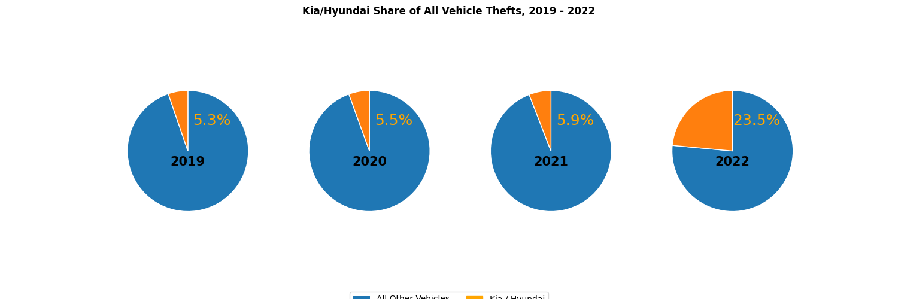

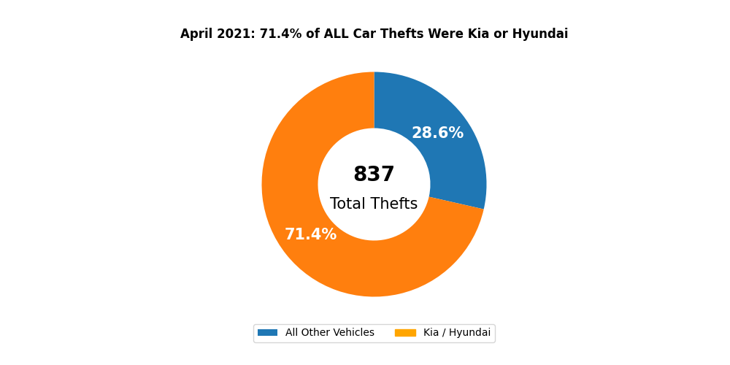

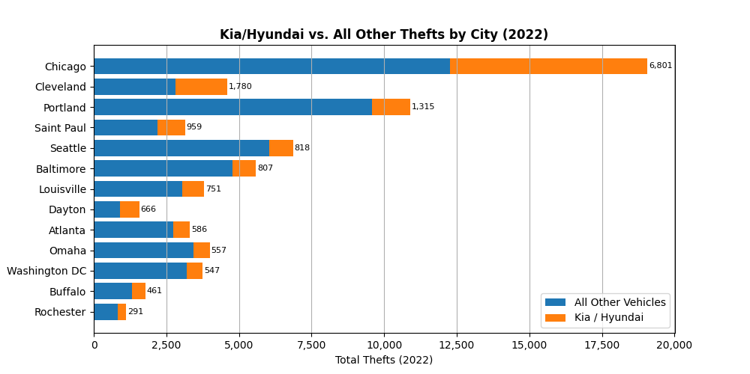

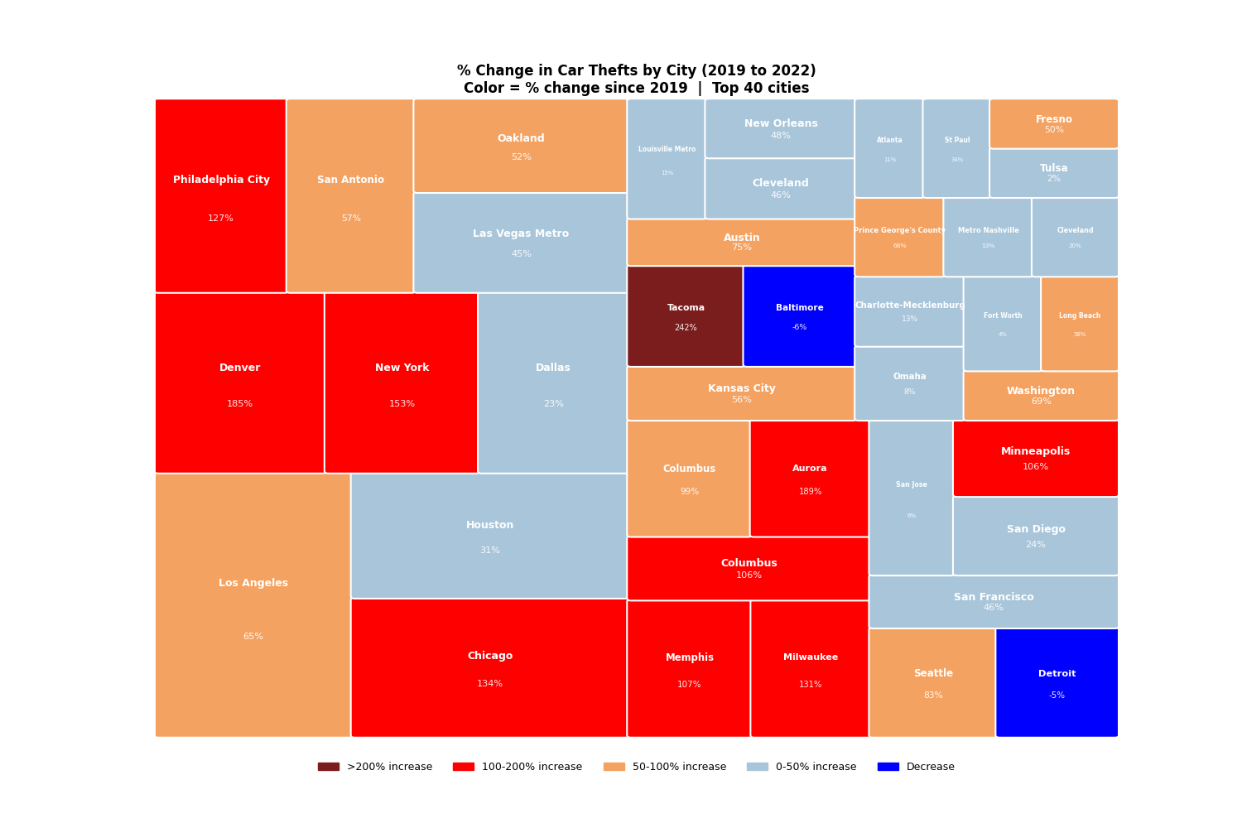

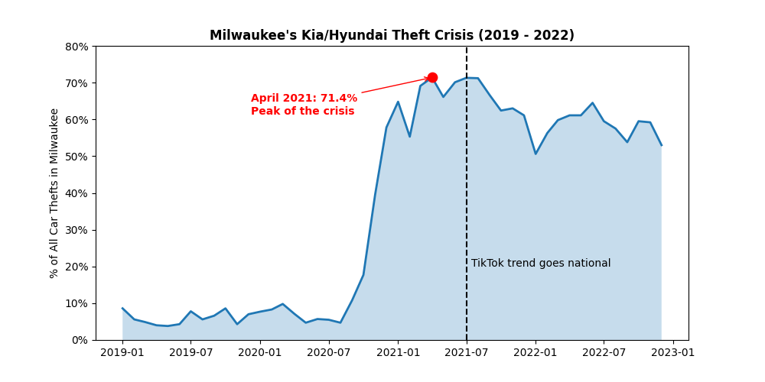

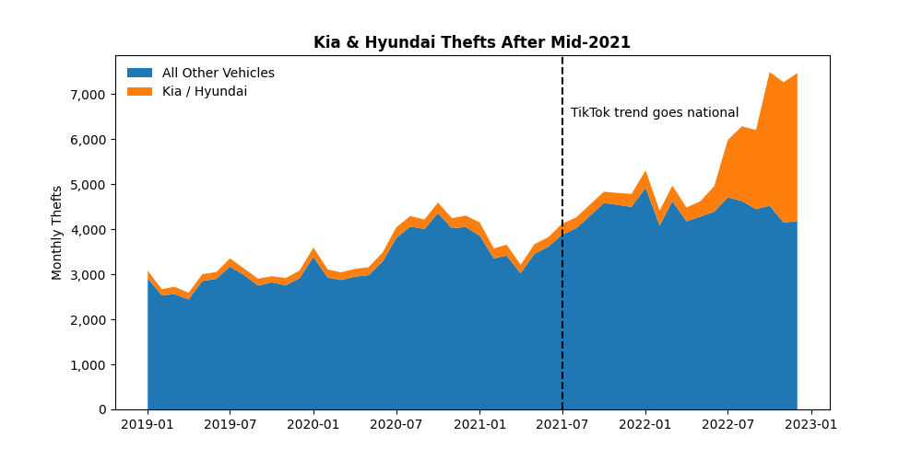

Ethical Considerations
Several ethical tensions exist in this story. First, the data was collected and reported by VICE/Motherboard media, not a neutral government agency. This means coverage gaps and selection bias in which cities were tracked could affect conclusions. Second, the "Kia Boys" framing carries racialized undertones in public discourse. This story deliberately avoids that angle and focuses blame squarely on the manufacturer's design failure and lobbying delays. Third, visualizing crime data by city risks stigmatizing communities already under stress. The treemap and bar charts were designed to show institutional failure, not neighborhood pathology. Finally, the call to action directs readers toward legal and regulatory remedies rather than vigilantism or punitive framing.

